**Prototype Description**

Our prototype was built using the Bootstrap web framework to allow for easy customization in how we want our interface to look. Bootstrap also has built-in classes to quickly create different aspects in our interface. With such limited amount of time to create an entire web system, having quick access to advanced features to create a good-looking interface is important. Not only does Bootstrap offer great customization in a speedy fashion, but also the ability to scale the interface to meet different screen size requirements. This is important in ensuring our interface meets some layout and navigation principles. This also touches upon some design principles such as, simplicity and flexibility. Our system is flexible because it allows the user to see our entire web site from a tiny screen on their phone without having to horizontally scroll through the desktop version of our interface. Also, being able to use our website on any device is an example of how our interface follows the simplicity design principle.

The two major features that were most worked on in our interface were the Course Catalog and Course Registration aspects of our system. This is because these two features are the most important aspects for making our system functional and meeting the efficiency usability goals. Therefore, it was these two features that were the first to undergo high-fidelity prototyping to allow the most time to fully develop their features.

**Course Catalog**

The Course Catalog system closely resembles what was shown in the sketches for our interface. This is because many users who tested the paper-prototype of our registration system liked the visualization aspects of the Course Catalog. Features such as, being able to compare multiple courses and getting a visual representation of a course and its pre-requisites seemed very helpful to the users. We believe that having a lot of visual representations of information is better than just showing clumps of text, allowing the users to build a better mental model of what’s going on. Thus, the user is able to quickly get their tasks done without having to decipher our interface. We believe that this part of our system will be successful because of the utility it offers the user. Not only can the user search for a course using many search filters, but the user can also compare these courses and see it’s pre-requisites all from the same area. These tools allow the user to become as productive in their task as possible, due to the large amount of utility offered.

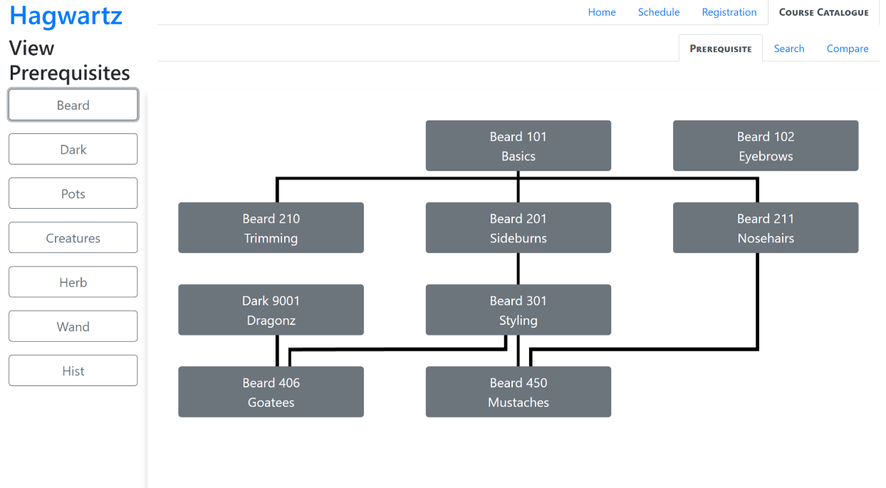

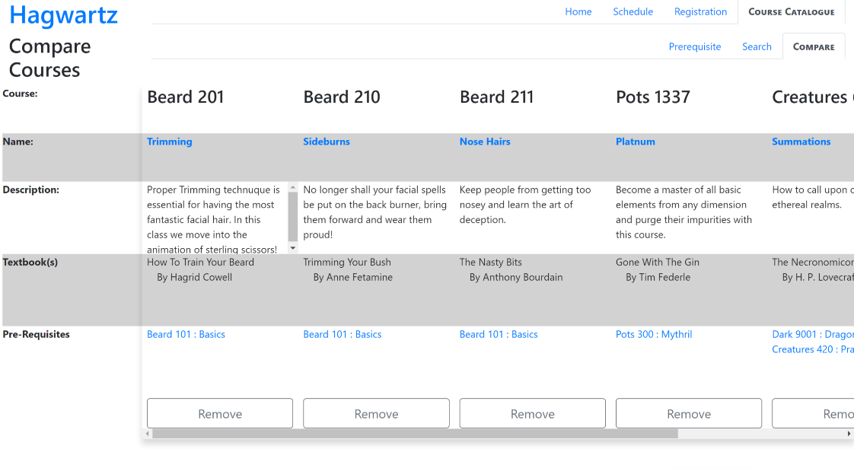

**Course Registration**

The Course Registration aspect of our interface also has many features that were seen with our paper-prototype. It features a visual layout of a student’s course schedule, the ability to add courses to your planner without fully registering for that course, and the ability to test what sections of a course fit within your schedule. When a course is added to your Planner it appears within the Registration Planner page. From the Registration Planner page, you can select different sections from that course and see how they will fit into your schedule. Depending on which section works with your schedule, you may register for that section and see it appear green on your schedule. There’s a legend on the Course Registration page indicating the status of your courses depending on the colour of the section within the schedule. This ties into the mapping design principle and how we’re leveraging that to help the user understand our system without having text everywhere. We also have used the safety design principle to give users a way to change their actions in the form of confirmation messages when dropping course sections.

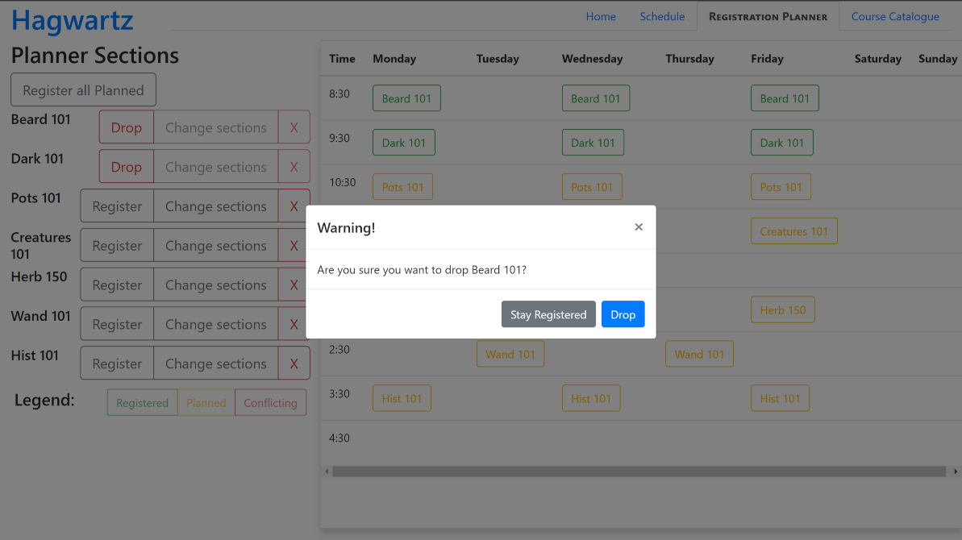

**Bugs**

There are a few minor bugs that are in the Course Registration and Course Catalog aspects of our system. A bug that is in the Course Catalog is when you try to see the pre-requisite graph of some departments, the previous pre-requisite graph does not disappear. Therefore, after clicking all the different departments you’re left with a very long pre-requisite graph.

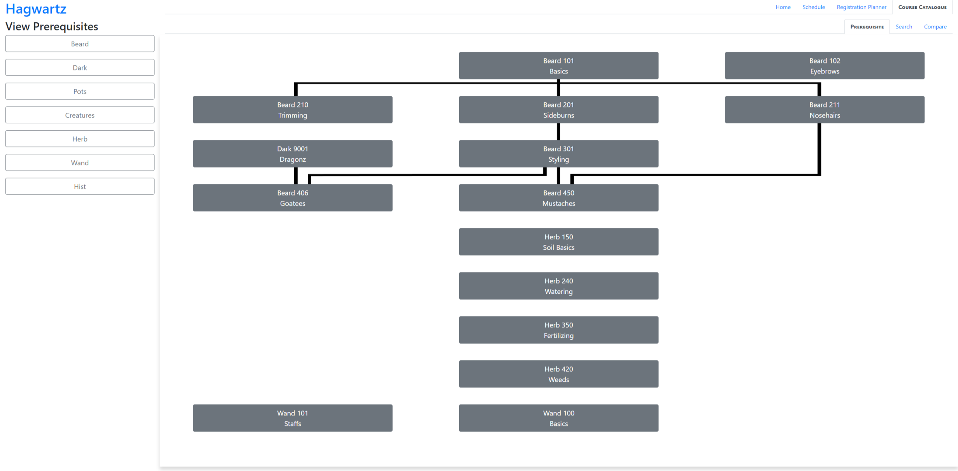

Many of the other “bugs” in our system aren’t really bugs but are more so uncompleted sections. Parts of the system such as the homepage and course schedule are unfinished because it was not the central focus of this prototype. However, some aspects that weren’t finished in the Course Catalog and Course Registration were features that were implemented thoroughly enough to prove the concept. This is seen in the Course Catalog where most of the search filters match up with the specific courses and are indicated to be a part of that course, but some courses do not have these indications. The image below demonstrates a course that hasn't indicated certain information, such as the number of credit hours, even though it has been selected.

